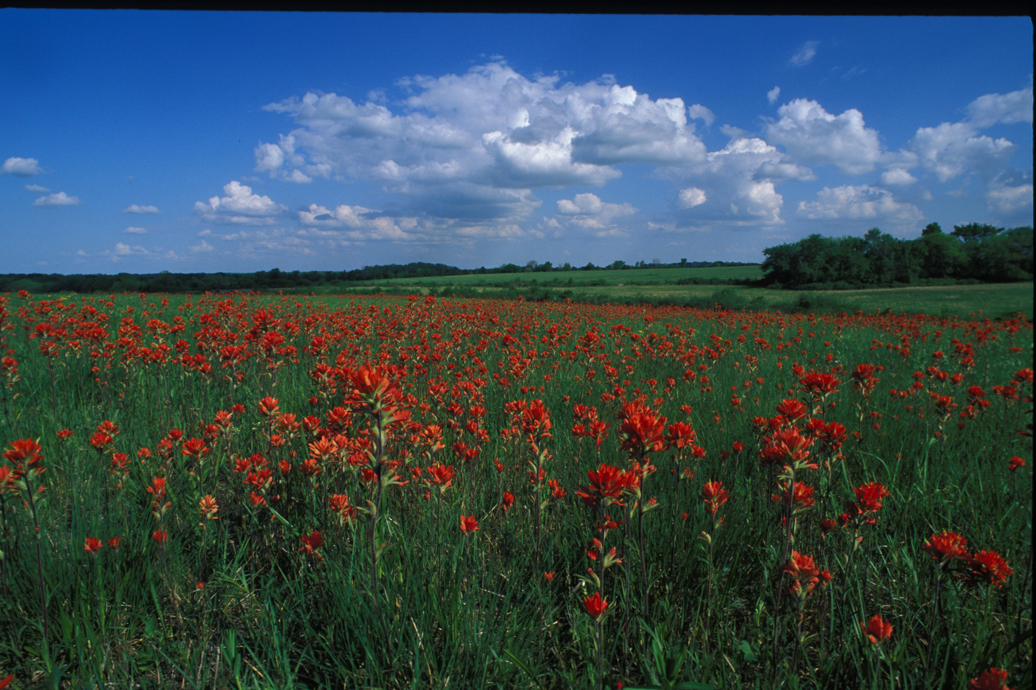
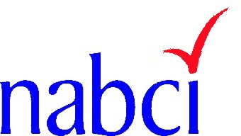
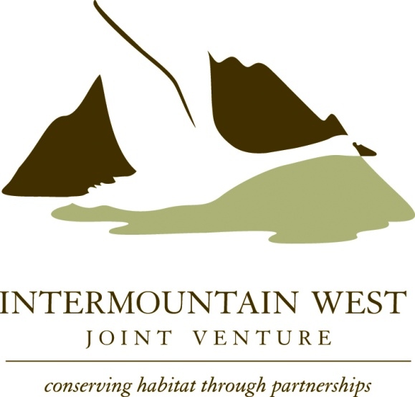
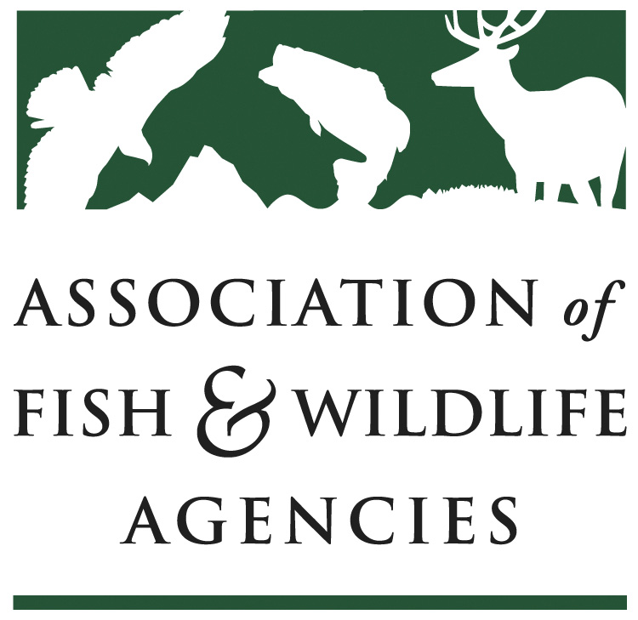
Delivering Fish and Wildlife Conservation:
Delivering Fish and Wildlife Conservation:
Building Farm Bill Capacity
NABCI Private Lands Subcommittee
August 2009
Building Farm Bill Capacity

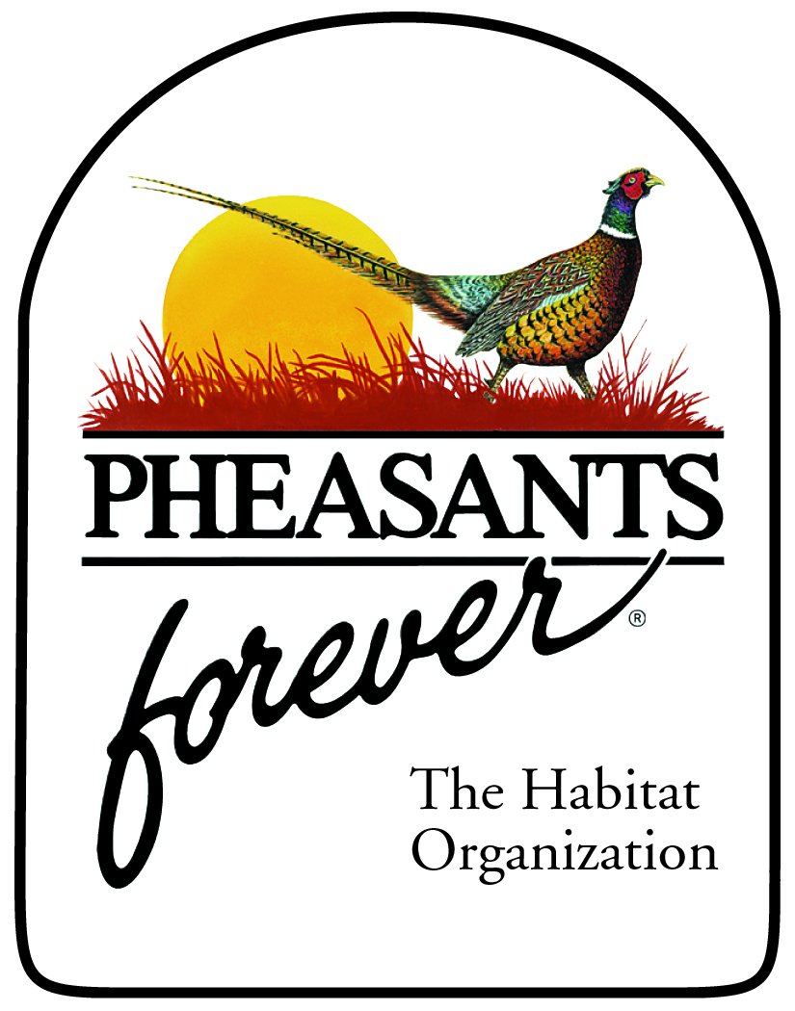
NABCI Private Lands Subcommittee
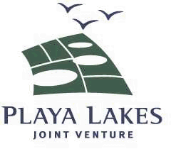
August 2009

Table of Contents

I Background of Report 3
II Context 3
III History and Current Biological Capacity 5
a. NRCS and Partner Biological Staffing Trends 5
b. Focusing Fish and Wildlife Conservation Practices 7
1. Riparian Practice Example 7
2. Wetland Practice Example 8
IV Prioritizing Programs for Fish and Wildlife 10
a. Using EQIP in Montana 10
b. Using WRP to regain function in Central Valley 11
c. Using CRP for Northern Bobwhite and Grassland Birds 12
V Need for More Biologists 12
a. The Technical Assistance versus Financial Assistance Dilemma 13
b. Training Needs 14
c. Streamlining Biology Capacity 15
VI Possible Ways to Increase Capacity to Deliver 16
VII Recommendations 17

The purpose of this report is to recommend actions to National Resources Conservation Service (NRCS) Leadership, State Fish and Wildlife Agency Directors, and Non-Governmental Organizations (NGOs) to shape biological capacity as necessary to effectively deliver Farm Bill technical and financial assistance for fish and wildlife habitat conservation.

Biologists accelerate fish and wildlife conservation through Farm Bill programs by:

- Bringing specialized fish and wildlife knowledge and habitat management skills into conservation planning.
- Marketing the fish and wildlife aspects of the Farm Bill programs and benefits of practices to farmers, ranchers, and other private landowners.
- Facilitating timely implementation of planning, contracting, and practice implementation necessary to bring habitat projects to fruition.
- Being locally involved and maintaining landowner trust.

The services provided by field-level habitat biologists are invaluable to NRCS staff, predominately trained in other disciplines, and also for the implementation of Farm Services Agency (FSA) programs. The results are very clear: The Farm Bill conservation programs are most successful for wildlife where there are boots on the ground in the form of biological technical assistance capacity—be it internal to NRCS or in collaboration with partners.

NRCS has provided vital leadership in developing biological delivery capacity over the decade and has worked effectively with the wildlife community to build strong partnerships. It is essential that NRCS and the wildlife community continue to grow this successful model during the term of the 2008 Farm Bill and into the future.

I. Background of Report

An informal working group representing Federal and State natural resources agencies, Joint Ventures, and fish and wildlife NGOs met at the September 2008 Association of Fish and Wildlife Agencies (AFWA) Annual Meeting to explore the issue of capacity to deliver Farm Bill conservation programs. This meeting followed efforts this past decade by AFWA, NRCS, Joint Ventures and NGOs to actively increase the number of NRCS biologists and Farm Bill cost-shared or “partner” biologists located in U.S. Department of Agriculture (USDA) Service Centers and within State Fish and Wildlife Agencies. NRCS has demonstrated strong commitment to building fish and wildlife conservation delivery capacity through numerous partnerships facilitated by cooperative agreements, contribution agreements, and other Technical Service Provider (TSP) arrangements.

II. Context

The Farm Bill is one of the nation’s most powerful tools for fish and wildlife conservation, due to (1) its significant funding; (2) its voluntary and private lands focus (that includes more than 70% of the US landscape); and (3) USDA Agencies that have built their base on financial and technical conservation assistance to farmers and ranchers since the 1930s.
NRCS has provided effective conservation technical assistance since its inception, successful in part due to its decentralized structure and continued emphasis and input from the state and local level. Strong consensus exists among the wildlife community and NRCS that the level of biological capacity at the local level (e.g., NRCS biologists, cost-shared Farm Bill biologists) is strongly correlated with wildlife conservation results achieved through the Farm Bill.

The 2008 Farm Bill Manager’s Report clearly directs the Secretary to develop partnerships to increase technical assistance, specifically noting that the vision of the 2002 Farm Bill to develop a private sector workforce (via Technical Service Providers) has largely been unsuccessful (see text from Page 62):

The demand for technical assistance exceeds the present supply of technical resources, and the private sector cadre envisioned in the 2002 Farm Bill has not developed. The modifications made in the substitute are intended to correct these deficiencies through authority for use of mandatory funds and multi-year contracts with third party providers, establishment of fair and reasonable payment rates, and a nationally consistent certification process. The requirement for approval of State-level certification criteria is intended to address the criticism that current requirements, particularly those added at the State level, result in a complicated and overly burdensome process that discourages participation.

The Managers expect that these changes will provide the certainty needed to encourage the development of a successful, skilled, and accountable third party provider sector, diminish the tension caused by tradeoffs between public and private sector resources, and make locally relevant conservation technical assistance from public and private sources increasingly available and accessible to producers. (Section 2706 of Conference substitute).

Fish and wildlife agencies and NGOs have invested significant resources and energy in shaping the Conservation Title of the Farm Bill, and have had a profound influence on the enacted policies, particularly related to the Conservation Reserve Program (CRP) and Wetland Reserve Program (WRP). In addition, the authorization and annual funding of the Wildlife Habitat Incentives Program (WHIP), Grassland Reserve Program (GRP), and Environmental Quality Incentives Program (EQIP) at-risk species emphasis has contributed substantially to fish and wildlife conservation.

Partnerships will be increasingly more important in the future as the 2008 Farm Bill marks a shift in policy towards an increase in funding for active conservation practice implementation on working lands and a reduction in funding for programs that retire sensitive agricultural lands.

This report describes the status of and need for increased biological capacity and provides recommendations to increase that capacity to successfully implement the conservation programs of the Farm Bill.

- History & Current Biology Capacity

The following section of the report addressees the NRCS and Partner Biological Staffing Trends and it also provides a summary of the work of the biologist in focusing Farm Bill conservation program delivery to achieve fish and wildlife conservation objectives.

- NRCS and Partner Biological Staffing Trends

According to a recent survey conducted by the AFWA, 38 states reported a total of 123.5 cost-shared partner biologists. In the past three years, NRCS has lost 21 percent of its own biologists across the country (from 177 to 140 positions). Figure 1 graphically depicts the trend for the regions— the East region lost 26; the Central gained 4; and the West lost 15. The reasons vary from changing workload, retirements without backfilling, or less technical assistance dollars to continue field-oriented conservation planning.

Figure 1: Trends in NRCS biology staffing

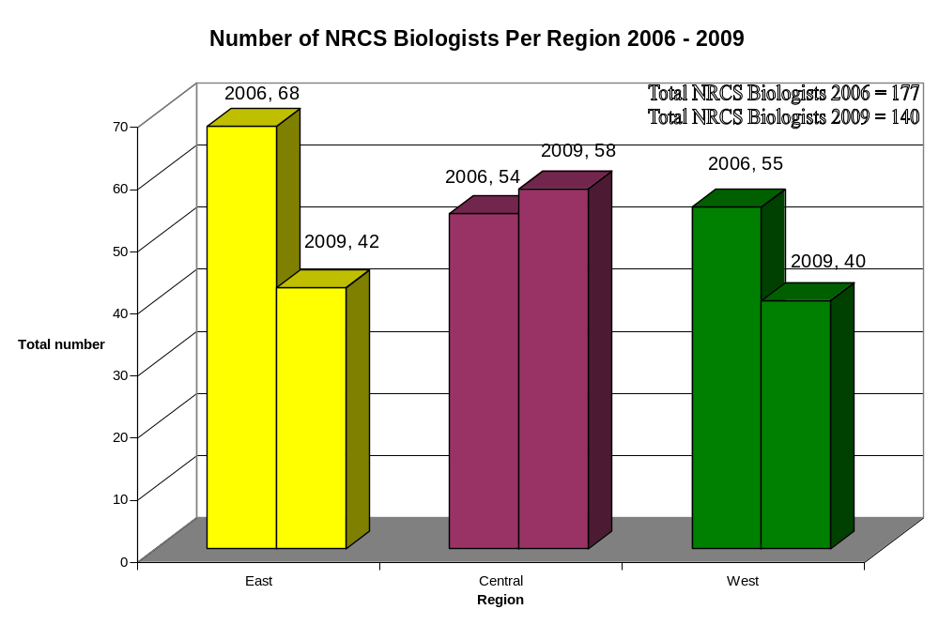
Figure 2 depicts the number of NRCS and Partner (a.ka. Farm Bill) biologists in 2006-2009 by State; The largest total contingent of biologists is 21 in Kentucky. Some states, such as California, Colorado, and Texas have built NRCS staff, while other states such as Ohio, Kentucky, Missouri, and Iowa have increased partnerships to deliver fish and wildlife conservation work. Staff numbers are not the only component of “capacity”. Training of all staff in fish and wildlife conservation allows for technically sound decisions and alternatives offered to private landowners. Also, the number of NRCS staff biologists reported includes biologists that may focus only on program oversight or only on environmental compliance (e.g. NEPA, Endangered Species, and Swampbuster). In general, the State Biologists employed by NRCS are substantially engaged in technology development and training whereas partner biologists typically devote most of their time and energy to working directly with producers at the Field Office level to encourage participation in Farm Bill programs.
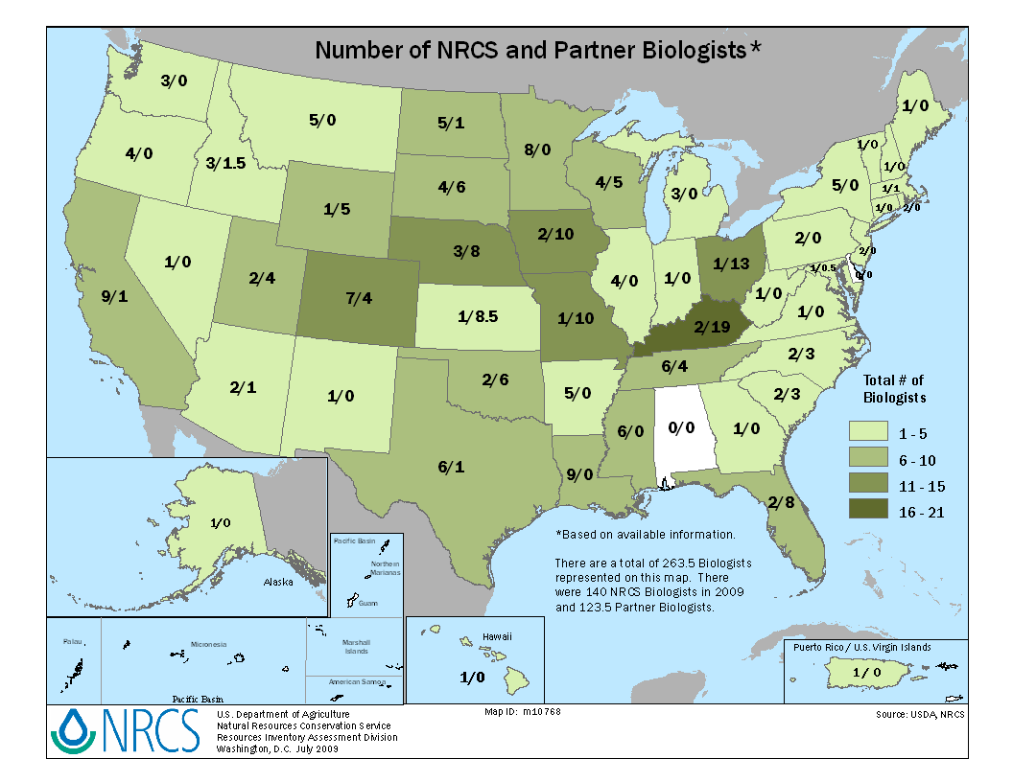
Figure 2: Number of NRCS and Partner Biologists

The number of partner biologists depicted in Figure 2 represents only those positions reported by the 38 state fish and wildlife agencies that responded to the AFWA questionnaire. Additional biologists are working on Farm Bill conservation program delivery through agreements between NRCS and other conservation groups, and may not be reflected herein. Thus, we stress that the data presented in Figure 2 represents a “snapshot in time” look at collaborative Farm Bill delivery capacity as reported by state fish and wildlife agencies, and is not all encompassing. However, it provides a good indication of the level of wildlife delivery capacity currently in place throughout the country.

The key point is that both NRCS biologists and partner biologists are needed to maximize the fish and wildlife benefits of Farm Bill conservation programs.

- Focusing Fish and Wildlife Practices

NRCS Performance Results System Data from 2000-2009 show the 13 non production-oriented biology discipline practices implemented on the U.S. landscape (Figure 3). These data indicate which States are doing the most on-the-ground conservation practice implementation for fish and wildlife. These data have been divided into terrestrial, stream, and wetland biology practices, as well as by practice.

Figure 3: Number of times all NRCS biology conservation practices were applied
on the U.S. landscape from 2000-2009
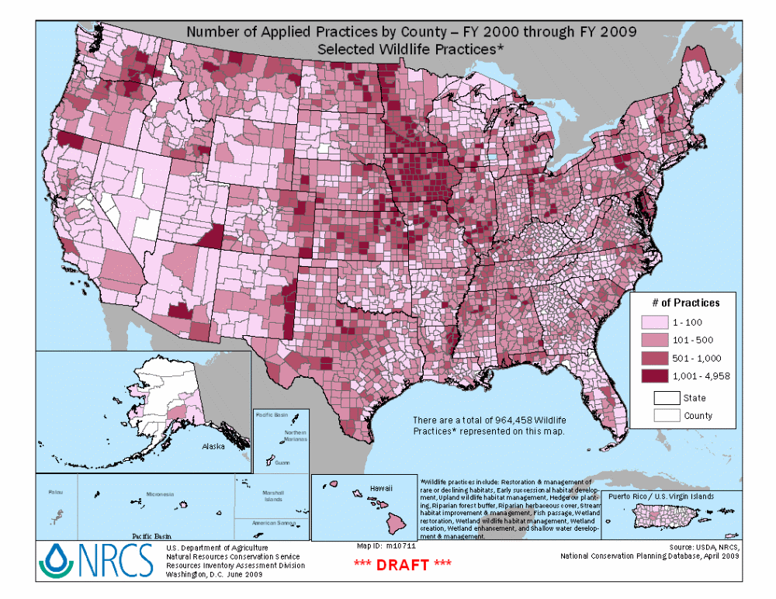
1. Riparian Corridors

One of the most common NRCS biology and forestry practices used to benefit both aquatic and terrestrial species is the Riparian Forest Buffer (Conservation Practice Standard number 391). Figure 4 illustrates the number of times this practice has been applied on the landscape (by county) from 2000-2009. Implementation of this practice can be explained in one State by biological capacity. Virginia NRCS established a riparian buffer team and saw to fruition stream conservation and restoration practices not included in adjoining States, as marked by a distinct boundary following State lines.

Figure 4: Number of times Riparian Forest Buffer practice has been
applied on the landscape (by county) from 2000-2009.
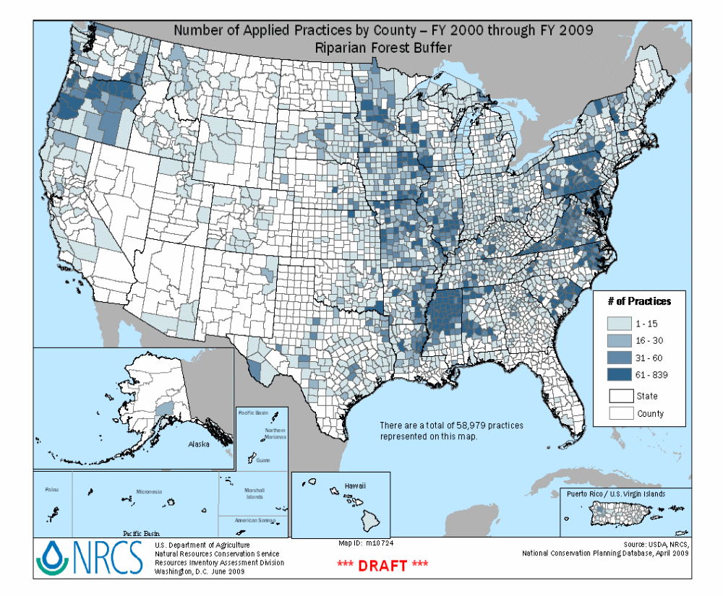

2. Habitat Restoration and Management

Figure 5 illustrates the number of times all NRCS wetland practices were applied in the past nine years. It is no coincidence that these data correlate well with the largest and oldest Joint Venture in the Prairie Pothole Region (Figure 6). The PPJV is a dynamic partnership that functions as a network and seeks partners at the local, regional, national and international level. The partnership involves Federal and State agencies, NGO conservation groups, private landowners, scientists, universities, policy makers, resource managers, corporations interested in conservation, communicators, Tribes and resource conservation districts, and land trusts among others.

Figure 5: Number of times all NRCS wetland conservation practices were applied
on the US landscape from 2000-2009.
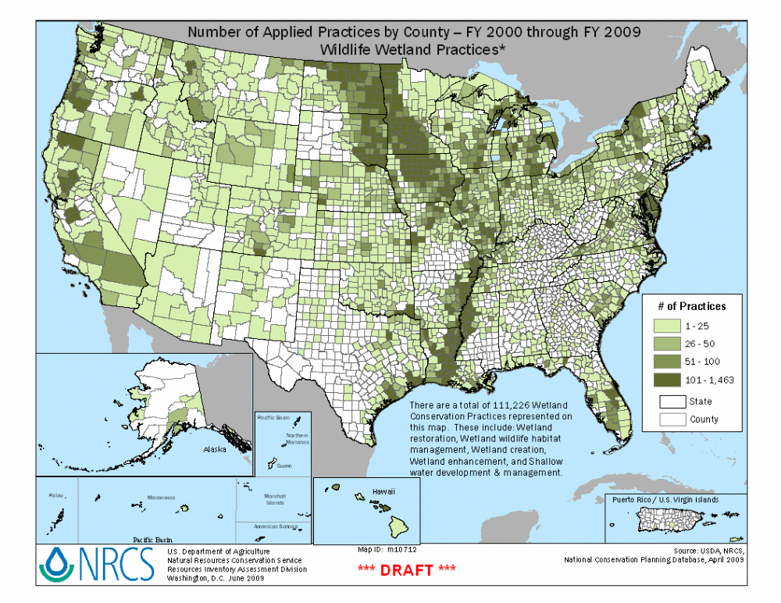

Figure 6: Prairie Pothole Joint Venture map

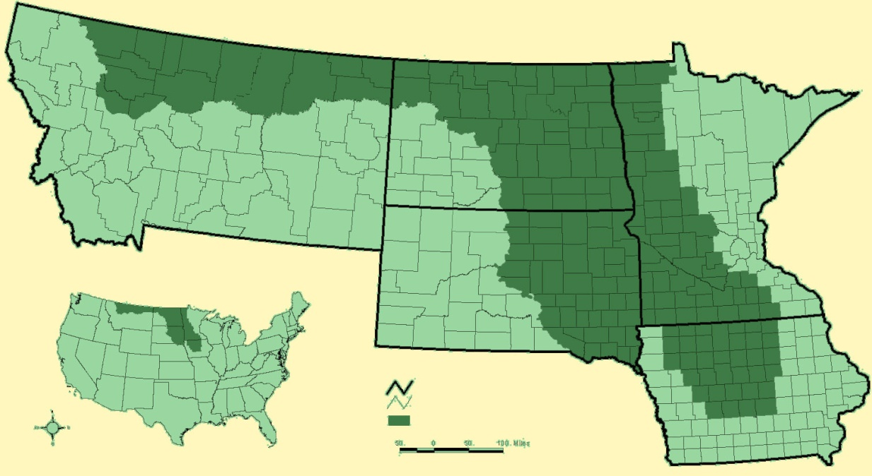

With the advent of NRCS easement programs in the early 1990s, NRCS also became a land management (advisory and contractual) agency with over 2 million acres in WRP alone under NRCS management supervision. While NRCS does not do the actual on-the-ground management, it serves to direct, approve, and recommend habitat management activities. Numerous studies have shown that properly managed lands (both upland and wetland) provide optimal functions and values for which the lands have been protected. Exotic and invasive species detection and control are reason alone to support proper management.

CRP mid-contract management and appropriate management recommendations have also become important as supported by numerous studies, agencies (USFWS, State Game and Fish Agencies) and NGOs (Pheasants Forever, Ducks Unlimited, The Nature Conservancy). For example, mid-contract management has resulted in substantial increases in grassland bird utilization of CRP fields.

IV. Prioritizing Programs for Fish and Wildlife

Habitat restoration that is well-planned at the farm or ranch level is often opportunistic because it is not focused on priority fish and wildlife needs or with a strategy to address key limiting factors. Farm Bill program ranking criteria helps NRCS prioritize projects, but may lack outreach to landowners with high potential for meaningful fish and wildlife conservation on their lands. NRCS currently has the opportunity to focus and increase outreach, partnership development, and Farm Bill program delivery on conservation targets identified through State Wildlife Action Plans, Joint Venture Implementation Plans, and other fish wildlife conservation plans. NRCS can be the catalyst for such efforts, working with Partner/Farm Bill Biologists through agreements to facilitate the development and implementation of special initiatives that address priority fish and wildlife needs. Examples include the following.

a) Using EQIP in Montana for Wildlife

NRCS State Conservationists have collaborated with the wildlife community to establish numerous wildlife-focused Environmental Quality Incentives Program (EQIP) Special Initiatives. Montana NRCS has been a leader in this arena, addressing the needs of bull trout, west slope cutthroat trout, arctic grayling, piping plovers, and grizzly bears. Since 2004, Montana NRCS has provided $1-2 million annually for specific fish and wildlife EQIP Special Initiatives. Montana Fish, Wildlife, and Parks, the Intermountain West Joint Venture, and other wildlife partners provided the science foundation for these initiatives by identifying priority species, limiting factors, and spatially explicit priorities within focal landscapes. The Special Initiatives have been strongly supported by farmers, ranchers, and the Montana State Technical Advisory Committee for their integration of the needs of agricultural producers. Interestingly, EQIP has become perhaps the most important Farm Bill conservation program for fish and wildlife in western Montana.

A cornerstone of Montana EQIP Special Initiatives has been to increase field-level biological delivery capacity. NRCS has partnered with a wide range of conservation organizations – including Montana Fish, Wildlife and Parks, Trout Unlimited, North Powell Conservation District, Blackfoot Challenge, and The Nature Conservancy. NRCS established increased biological staff at the field level, funded primarily through Contribution Agreements..

NRCS also provided approximately $1.3 million in EQIP funding over two years to the Bull Trout/Westslope Cutthroat Trout Special Initiative, which was leveraged by $525,000 in partner contributions. It resulted in the restoration of over 35,000 feet of complex stream channels; 10 miles of riparian habitat improvement through fencing, off-site water development; re-vegetation; improvement or replacement of 17 water control structures to make fish-friendly systems; the installation of two fish screens and one fish ladder; and major improvements to grazing systems on nine ranches. Three of the four major stream restoration projects were completed within 18 months of contracting, a testament to the increased biological capacity, provided by Trout Unlimited and the North Powell Conservation District in partnership with NRCS.

b) Using the Wetland Reserve Program to Increase Functions in Central Valley, California

The Wetland Reserve Program (WRP) is the Nation’s most significant wetland restoration program with over 2 million acres enrolled. NRCS has also made outstanding progress in restoring microtopography and vegetative conditions to maximize aquatic and terrestrial wildlife values. Wildlife conservation partnerships, perhaps more so than with any other Farm Bill program delivered by NRCS, have shaped WRP. In many instances, WRP enrollment and wetland restoration have been facilitated by NRCS’ partnerships with nongovernmental organizations and state fish and wildlife agencies. The power of the program is particularly evident in the Lower Mississippi Valley where over 500,000 acres are currently enrolled. Ducks Unlimited played an instrumental role in WRP implementation by partnering with NRCS to provide biological and engineering assistance necessary to restore wetlands and achieve the program’s intended purpose.

The Central Valley of California represents perhaps the best example of WRP’s significant role in achieving continental wildlife conservation objectives. Approximately 95% of the Valley’s historic wetlands had been lost to agriculture, flood control, and development at the time WRP was authorized in the 1990 Farm Bill. Since that time, over 100,000 acres of WRP have been enrolled in California, mostly in the Central Valley. WRP has been the greatest single contributor to achievement of wetland restoration objectives established by the Central Valley Joint Venture to support wintering waterfowl populations at continental goals established by the North American Waterfowl Management Plan. NRCS has partnered with the California Waterfowl Association, California Department of Fish and Game, and other entities to establish key biological delivery capacity at the field level to assist NRCS Field Offices with WRP implementation over the last decade. In response, the wildlife community has contributed significant millions of dollars of cost-share funding to WRP easement acquisition, wetland restoration, and habitat management. Again, the success of WRP in the Central Valley is due to partnerships and biological staff capacity.

c) Using CRP for Northern Bobwhite and Grassland Birds

Partnerships and capacity building go beyond practice implementation and relate to other important aspects of Farm Bill, such as monitoring the benefits of programs to wildlife. In 2004, the USDA-Farm Service Agency (FSA) implemented the Habitat Buffers for Upland Birds (CP33) practice as part of the Continuous Conservation Reserve Program (CCRP). The FSA allocated 250,000 CP33 acres to 35 states to be actively managed over a period of 10 years and charged the Southeast Quail Study Group (SEQSG) with the development of a CP33 monitoring protocol with the goal of generating measures of population response for Northern Bobwhite and other priority bird species. The FSA adopted the monitoring protocol developed by the SEQSG and encouraged states with CP33 allocation to participate in coordinated monitoring. This work is helping inform future technology development and implementation of CRP to achieve maximum wildlife benefits.

V. Need for More Biologists:

The most effective way to deliver quality conservation programs is to have knowledgeable people at all levels of the planning and implementation process. This begins with shaping programs and policies at national, state and local levels and ultimately delivering them to landowners and agriculture producers. Previous surveys indicated that many NRCS soil conservationists and planners have not mentioned fish and wildlife opportunities to producers. To address this issue, NRCS has entered into agreements with state wildlife agencies and NGOs to place fish and wildlife biologists in USDA Service Centers to work directly with producers and landowners. These biologists are sharing information with USDA staff about how conservation programs can benefit wildlife, while addressing other resource concerns. Partner biologists can help coordinate landowner workshops to generate interest in programs. Some States have developed conservation partnerships composed of agencies and NGOs that help shape conservation policy and programs. Partners can supplement missing positions and expertise needs. Some also have dedicated local volunteers to assist in fundraising and conservation program implementation at the grassroots level.

It has been observed that landowners are more accurately scored and score higher in the ranking processes associated with the different programs (i.e. under CRP, WHIP, WRP, EQIP) when assisted by biologists because of the in-depth knowledge that Farm Bill biologist have concerning conservation practices and program policies and rules. Farm Bill biologists encourage larger wetlands, wider stream buffers, wider field border practices and diverse seeding mixes. These relatively minor recommendations are ultimately better for wildlife, soil conditions, water quality, and aid in sequestering carbon. Farm Bill biologists are often the first to identify problems with conservation programs or practices, and notify staff who can address it at a state or federal level for clarification or change.

- The Technical Assistance versus Financial Assistance Dilemma

NRCS total staffing levels have increased by 30 percent, while program dollars have doubled. Figure 7 shows NRCS’ total Financial Assistance (FA) funding compared with total Technical Assistance (TA) funding from 2002 to 2008. TA dollars increased by 38% from 2000-2008; however, FA dollars increased by 75% in the same time period.

Figure 7: NRCS’ total Financial Assistance (FA) funding compared with total
Technical Assistance (TA) funding from 2002 to 2008
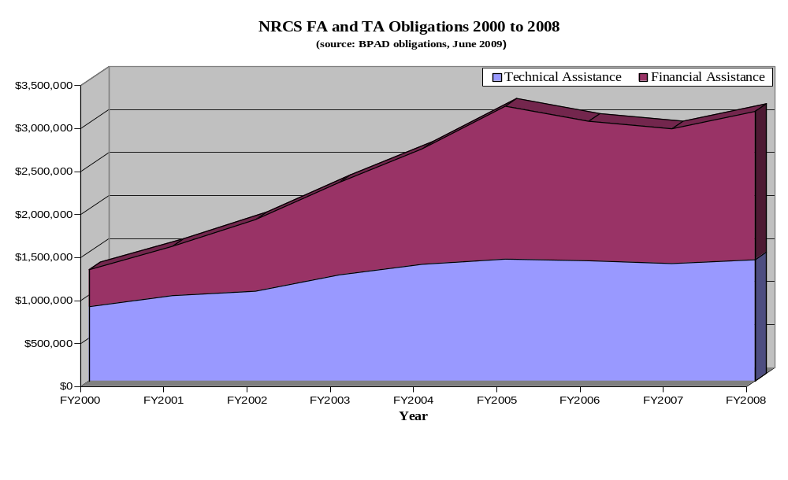
This shift from salary to direct cost-share assistance is important due to basic hiring, but there has also been a shift in workload from technical to financial management. The 2008 financial audit has mandated that NRCS work harder to ensure contract and financial accountability. This has resulted in a vastly increased contract management workload that has reduced the ability of NRCS staff (largely generalist soil conservationists) to conduct conservation planning. In addition, new mandates such as comprehensive nutrient management planning (AFO-CAFO) needed to help producers meet regulatory requirements require focused planning, further reducing the ability of NRCS staff to plan wildlife practices. According to a recent survey by the AFWA, the 35 states that responded indicated they would be able to use 240 additional biologists (permanent or cost-shared) positions to implement conservation programs.

b) Training Needs

Capacity is more than staff numbers; it includes technical fish and wildlife training of all NRCS staff. In a 2001 sample poll, nearly half of NRCS field personnel believe they are not receiving appropriate training to become proficient in providing science-based technical assistance on grazing, wildlife and forestlands. During the past 18 years, the total number of technical NRCS national courses offered has declined. In 1991, technical courses represented 83 percent of all classes; in 2001, the proportion was 46 percent; in 2009, the proportion of technical courses was also 46 percent, although the mixture of grazing, forest, and wildlife-oriented courses dropped from 28 percent of all to 10 percent range and wetlands (see Figure 8). NRCS developed a comprehensive Fish and Wildlife Conservation and Management course in 2005 but it has been implemented sparingly due to budget restrictions and other issues. In 2009, no fish and wildlife courses were offered.
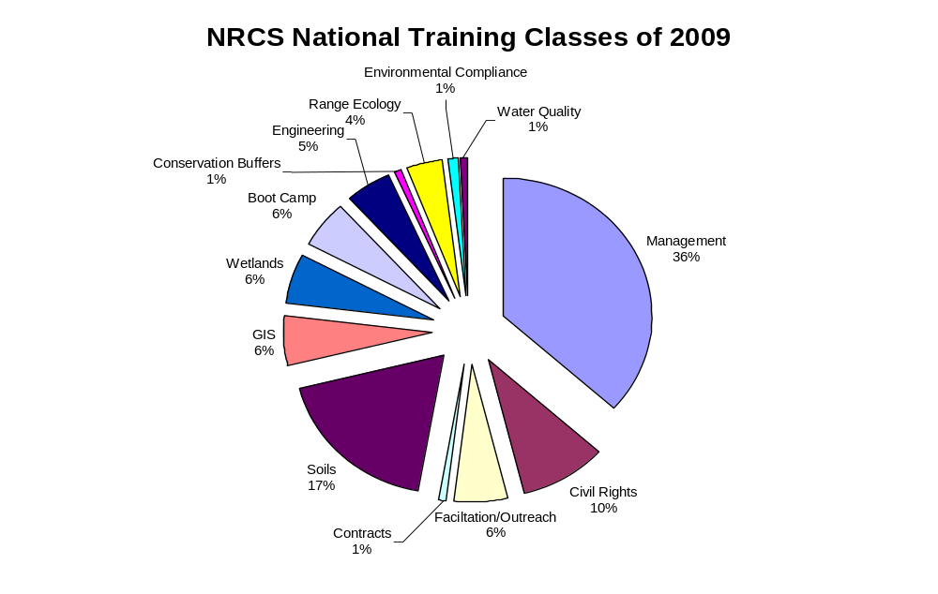
Figure 8: NRCS Training Classes in 2009

c) Streamlining Biology Capacity

The majority of NRCS State Biologists are also the State-level “compliance” officers for the National Environmental Policy Act (NEPA) and the Endangered Species Act (ESA). In fact, in some States, keeping NRCS program project work in environmental compliance can be more than a full time job. As a federal Agency, NRCS cannot delegate ESA authority. However, it can work with the Fish and Wildlife authorities at the Federal and State level to make the process more efficient. One way to do that is to create programmatic informal or formal consultation agreements. The following is an example of one NRCS State Biologists’ action to streamline the process.

In January, Utah NRCS received two programmatic Biological Opinions (BO) from the U.S. Fish & Wildlife Service (FWS), covering consultation responsibilities for Farm Bill program funding of projects related to Safe Harbor Agreements (SHAs). The programmatic BOs cover FWS and NRCS actions that are likely to adversely affect the southwestern willow flycatcher, and three associated species and Utah prairie dog.

The Color Country Resource Conservation and Development Council (RC&D) is the permit holder for an umbrella SHA for southwestern willow flycatcher. Typical activities funded by NRCS include streambank stabilization, control of invasive Tamarisk, and re-establishment of native riparian vegetation. The Panoramaland RC&D is the permit holder for an umbrella SHA for Utah prairie dog. Typical activities funded by NRCS include brush management, range seeding, and prescribed grazing.

Individual landowners receive certificates of inclusion to participate under the RC&D’s umbrella SHAs. This eliminates the need to develop individual SHAs for each landowner, and the environmental compliance responsibilities associated with each one.

Since the Utah FWS Ecological Services office also needed to consult with their Region 6 office under Section 7 in order to issue the incidental take permit associated with the SHAs, FWS staff also completed the biological assessments necessary to cover NRCS funding actions.

In summary, biologists are:

- More likely to bring in other partners for fish and wildlife projects not eligible for Farm Bill programs;
- Expert trainers of NRCS and other staff;
- Innovative and have ideas to incorporate fish and wildlife into all Farm Bill programs;
- Best at bundling practices for comprehensive fish and wildlife benefits;
- Play a key role in the rapid recruitment of landowners and subsequent obligation of Recovery Act funding; and
- Often the point of contact for mid-contract management recommendations for CRP projects.

VI. Possible Ways to Increase our Capacity to Deliver

Funding for staff capacity is typically the limiting factor affecting agencies' and organizations' capacity to meet conservation goals and objectives. By working with State fish and wildlife agencies and conservation NGOs, NRCS can gain valuable expertise and assistance to help accelerate the delivery of conservation practices and programs on private lands as well as meet mutual conservation goals and objectives.

There are a number of different kinds of agreements that NRCS, state fish and wildlife agencies, and NGOs have signed to help deliver Farm Bill conservation programs— contribution, cooperative, Interpersonnel, and technical service provider agreements as well as contracts through Request For Proposals. Conservation NGOs have entered into agreements with NRCS and state fish and wildlife agencies (and vice versa) to assist with program delivery to accommodate hiring freezes, budget restrictions, or other limiting factors within a state. Below are some success stories that demonstrate how partnerships can put more financial assistance dollars in landowner's pockets for conservation practices that achieve mutual priorities, goals and objectives, and produce more and higher-quality habitat on-the-ground for fish and wildlife.

The following provides an overview of workings of two examples successful agreements.

Nebraska Farm Bill Wildlife Biologists:

NRCS and the Nebraska Game and Parks Commission (NGPC) have developed one of the nation’s most effective agreements for Farm Bill wildlife conservation. Funded through a Cooperative Agreement between NRCS and NGPC, the current split of costs is 85% NRCS and 15% Commission. Nebraska NRCS completed a request for proposals (RFP) for wildlife biology technical assistance, which allowed for negotiation of a higher rate of federal cost than the Contribution Agreements used in most other states. This arrangement made sense because the goal was to hire new full time staff dedicated to providing wildlife technical assistance on all Farm Bill conservation programs. Funds are reimbursed to the Commission based on the deliverables produced, with a “cap” based on the full salary of employed biologists. Positions are hired and held by Pheasants Forever (6 positions), Ducks Unlimited (1 position), and Rocky Mountain Bird Observatory (1 position). NGPC provides vehicles and travel costs, NGO partners provide overhead costs for positions (including benefits), and NRCS provides office space and USDA computers. Supervision of the positions is shared between all 3 partners. The following is a short summary of work products from this partnership since September of 2007:

- 275 conservation plans
- 268 Farm bill contracts (CRP, EQIP, WHIP, WRP)
- design and planting of nearly 14,000 acres of seeded perennial cover
- design and planting of over 35,000 linear feet of shrub and tree plantings
- design and implementation of wildlife management practices (e.g. early successional habitat management, prescribed burning, prescribed grazing) on over 30,000 acres
- design and restoration activities on over 3,500 acres of wetlands
- design of over 23,500 linear feet of streambank and shoreline protection
During the last 2 years, biologists have completed more deliverables than required for reimbursement by NRCS, which reflects how efficient this partnership has been in providing technical assistance to landowners. Currently, the Commission and NGO partners are working on efforts to further expand the number of biologists hired under this Cooperative Agreement (written with the potential to increase up to 12 positions, dependent on funding available from NRCS, Commission, and NGO partners). This partnership has been very successful due to the coordination among all partners with a shared goal of improving wildlife related technical assistance to landowners enrolling in Farm Bill conservation programs. The partnership ultimately seeks to build delivery capacity in each of the Biologically Unique Landscapes as identified in the Nebraska Natural legacy Project (State Wildlife Action Plan).

Colorado Private Land Wildlife Biologist Program:

The Private Lands Wildlife Biologist Program started in February 2003 when the Natural Resources Conservation Service, and the Colorado Division of Wildlife (CDOW), entered into a Joint Agreement to place four wildlife biologists into NRCS offices. Funding for the program is provided by the NRCS with a 1:1 match from the CDOW. In addition to the funds for biologist salaries, the NRCS also provides office space, vehicles, and related logistical support. The CDOW matches the NRCS dollars through direct expenditures and staff time spent on Farm Bill conservation programs. Rocky Mountain Bird Observatory (RMBO) operates the program cooperatively with the NRCS and CDOW and will leverage additional funding for on the ground habitat enhancement efforts.

In August of 2008 RMBO received the contract to coordinate the program. This multi-organization partnership is the result of a consensus that private land species and habitat conservation efforts in Colorado needed to be strengthened. The program provides technical resources to landowners and other land managers to more fully incorporate wildlife management into their conservation efforts utilizing Farm Bill and other conservation programs. By integrating the CDOW and RMBO expertise with the NRCS expertise and resources the Private Lands Wildlife Biologist Program brings the best of all organizations to assist Colorado’s landowners. The Intermountain West Joint Venture is also currently providing financial support to this effective program.

VII. Recommendations

External Staffing (Partner/Farm Bill Biologists):

- The cooperative partnerships currently employed are critical to deliver effective Farm Bill programs and will continue to do so. NRCS should employ maximum flexibility and creativity within their statutory authority to work with the wildlife community to build additional fish and wildlife capacity at the Field Office level through cooperative agreements, contribution agreements, and other technical service provider arrangements.

- State fish and wildlife agencies should explore options for developing long-term commitments to increase Farm Bill delivery capacity in priority landscapes, perhaps best executed thoroughly competitively bid Cooperative Agreements with NRCS. An excellent model for future growth in this arena is the well-established partnership between Nebraska NRCS and Nebraska Game and Parks Commission.

- Private foundations, non-governmental conservation organizations, Joint Ventures, corporations, and other fish and wildlife partnerships should carefully evaluate the “return on investments” of conservation funding in increased Farm Bill biological delivery capacity – and, if these analyses indicate high potential, develop a partnership with NRCS to build capacity. In many cases, Farm Bill funding that could be used for habitat projects is being under-utilized for those purposes due to the lack of biological capacity in USDA Service Centers. This is truly new money in terms of fish and wildlife habitat conservation.

Internal Staffing (NRCS Biologists):

- NRCS biology staffing has decreased while the need for biology technical assistance has increased dramatically. While it is recognized that additional positions are difficult to obtain, they are definitely warranted due to the habitat focus of many Farm Bill programs. At the very least, NRCS needs to recoup the loss of the 37 biologist positions lost in the last three years. Ideally, an additional 2-3 biologist per state are needed to deliver biological information at the State’s regional level. This could be accomplished through additional staff or by the shift of some of the agency’s core soil scientist staff to biology staffing since the focus of soil conservation is now only one of many NRCS components. If NRCS stays within the current direction of biology staffing, the agency will lose valuable institutional knowledge and the programs could become more separate from on the ground application. Having full-time career biologist protects the training investment in the personnel and reduces the training time.

Farm Services Agency:

- FSA should pursue additional funding to support the increased demand for technical assistance to improve CRP wildlife values and re-target CRP enrollment in pivotal landscapes for priority wildlife (e.g., Playa Lakes Region for lesser prairie chicken).

Whether it is a corn field in Nebraska, rangeland in Montana or a wetland in Louisiana, NRCS plays a key role in recommendations for their management. Our partnership strongly believes that additional growth in the biological arena will provide significant benefits to NRCS, FSA and their customers in achieving the fish and wildlife objectives of Farm Bill conservation programs.

